**Bilkent University**

Department of Computer Engineering

CS 319- Object Oriented Software Engineering   
Quantum Chess

Incredible in Thought

**Final Report**

Group 2A

November 4, 2017

Contents

1. Implementation & User Guide 3

Implementation 3

User Guide 4

2. Change in the Design 5

3. What to Do Next 5

4. Conclusion 6

What we have learnt: 6

# 1. Implementation & User Guide

## Implementation

We started our implementation immediately after the Analysis Report. The first step was in learning more about drawing 2D graphics with Java since all the program will be created in Java including the graphics. We decided to use Active Rendering strategy such that our game will run better. We created the playing board. The necessary pieces are also created and they incorporate all the necessary data. The piece movements have been implemented as well as the detection of collision between pieces. Furthermore the power ups are considered in the background but they are not yet implemented fully to be shown visually. The drawing graphics have been all implemented where the pieces can be seen, possible movements can be seen and the board can be seen. The total implementation has resulted in an almost normal check game, further implementation will add the other necessary features.

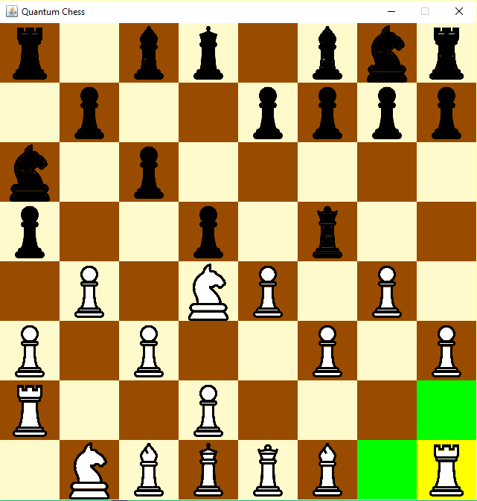

Figure 1: The Chess Game

## User Guide

During the gameplay the users’ whose turn is will select a piece that is theirs. The selection will be indicated by a change in the background of the piece with a yellow color (as shown in Figure 1). The possible movements where the player can move the selected piece are indicated with a green color (as shown in Figure 1). The player cannot move the piece to a location that is not specified.

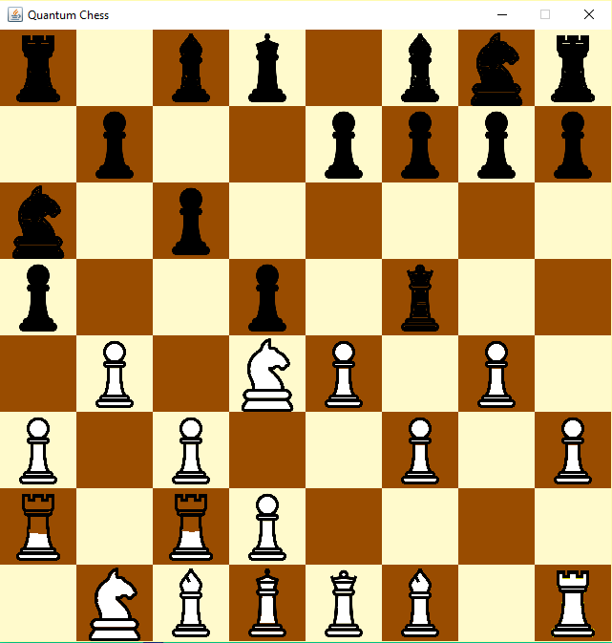The player can use also the power ups. They are not implemented yet, however they are illustrated through the following pictures. Quantum superposition is activated by the user of a piece, whereby a piece is at two positions at once. It can be seen in Figure 2 where the rook is in superposition and how the superposition will be indicated. The player will select his piece and the position where the piece should be in superposition. The piece then will be half at the position where it was before and half at the new position.

Figure 2: Quantum Superposition

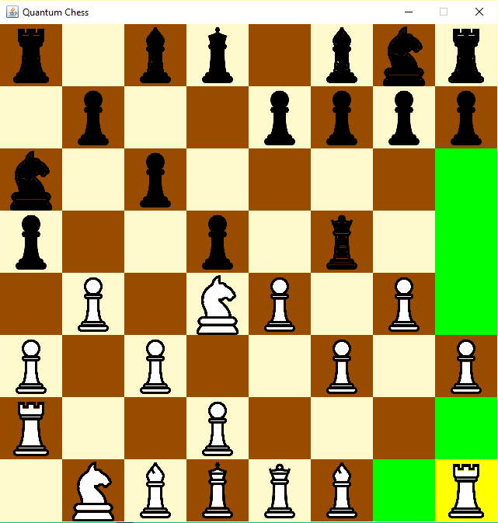

Quantum Tunneling allows the user of the piece to go through one of his pieces. The activation of this power up is illustrated in Figure 2. It can be observed that after the activation of the power up the piece can be moved up to the enemies’ piece and it is allowed to move only in the positions which would be valid if the piece would not be blocked.

Figure 3: Quantum Tunneling

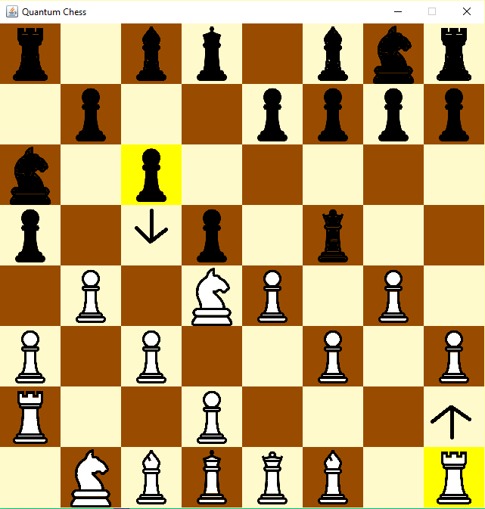

Quantum Entanglement allows the user of a piece to entangle his piece with a piece of the enemy. It can be observed that the entangled piece (Pawn) will be forced to move the same as the entangler (Rook). The entanglement will not be allowed if the movement is not possible by the enemies’ piece. No entanglement with pieces from the same player.

Figure 4: Quantum Entanglement

# 2. Change in the Design

As it is mentioned before there are some significant differences between Quantum Chess and the classic chess. It may be complicated to understand for users who are unfamiliar with the game. So, we give players some detailed knowledge about how to play the game. After clicking “Help” button on the main menu. Users are able to access information about rules of the game on Help page. But, if time requires and we deal with our issues, it is planned to put a visual tutorial. Since, we believe that demonstrating visuals is easier to comprehend for players. In this tutorial, some instructions will be given to users. Users are desired to click pieces and it will be shown that which locations the pieces can move and how they can use the power-ups. Thanks to tutorial, players will be trained as soon as possible.

# 3. What to Do Next

* **Implementation of players:**

Player class does not included the implementation yet. It is planned to implement the chess game without quantum powerups and players in the first iteration and after implement the parts which are specific to the QuantumChessGame.

* **Implementation of QuantumPowerUps**:

Since the game does not have player at this moment, QuantumPowerUps, which are belonging to players, are not implemented yet. However, movements regarding to the powerups are considered for the implementation. Therefore, powerups are considered at the backend operations but not implemented at the front-end.

* **Game Screens:**

We are currently working on the game screens and their intent with controllers. Main menu, game play menu, help menu and credits menu will be implemented after the first iteration. The most difficult part of the game play menu, board, is implemented in the first iteration.

# 4. Conclusion

## What we have learnt:

We choose this project to learn more about Quantum Chess, design it and develop this game for people who are curious about chess game. When we design this game we learn a lot of thing about Object Oriented Software Engineering. As a team what we learnt listed below:

* Our group members understand that group projects can promote important intellectual and social skills and help to prepare us for a work world in which teamwork are increasingly the norm.
* We understand that after graduating what we can do in our field.
* This project was a good chance to improve our Object-Oriented skills and all of the group members benefit from this chance to improve their skills
* We develop program in Intellij Idea it means that we improve our coding and using IDE skills
* We understand the concept behind MVC and the advantages it offers.
* Our group members improved their algorithms when we try to implement “Quantum Tunneling”, “Quantum Superposition” and “Quantum Entanglement”.